Spaghetti Bolognese

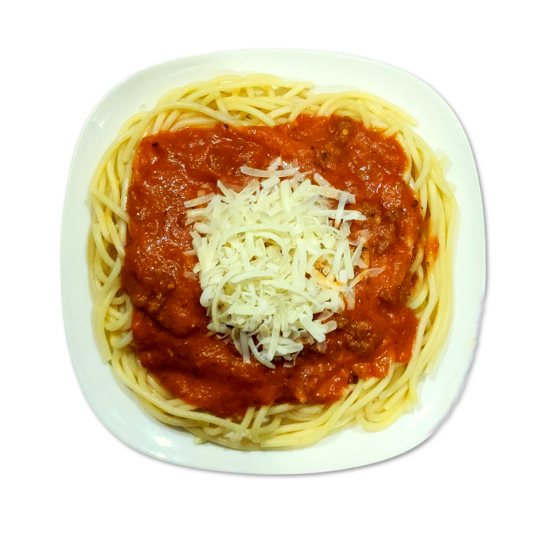

Spaghetti Bolognese

**Made from scratch meat sauce, real grated cheese.**

**Allergens**

Contains Milk, Eggs, Wheat.



Order Page Thumbnail

Information Pop-Up Context Menu

Order Pop-Up Context Menu Sample 1

Spaghetti Bolognese



Order Pop-Up Context Menu Sample 2

Spaghetti Bolognese



**- 0 + Extra Cheese 199**

**- 1 +**

**Regular 775**

**Large 975**

**Party Tray 2475**

**ADD TO ORDER**

**ADD TO ORDER**

**Regular 775**

**Large 975**

**Party Tray 2475**

**- 2 +**

**- 4 + Extra Cheese 199**